**Ytterby Project – Up to 93% Heavy Rare Earths**

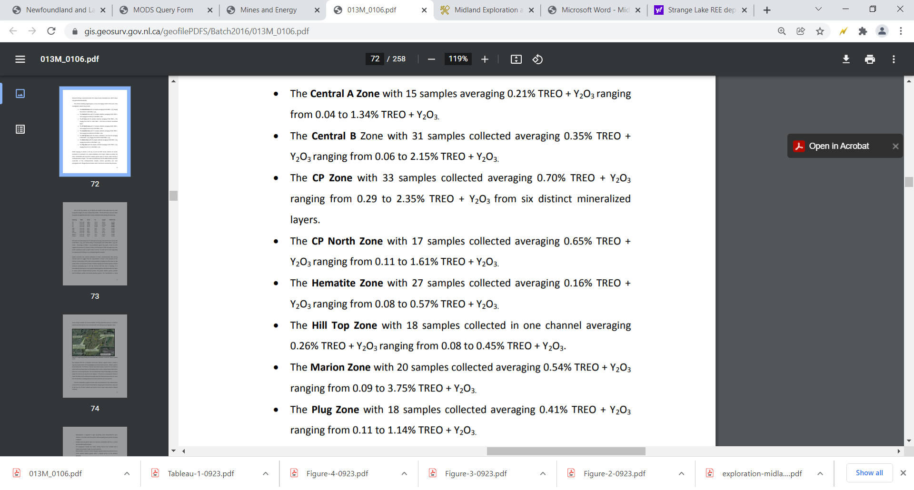

Retrieved from *Bourassa, et. al.,* *(2012)*